**In20-S4-CS3063 – Theory of Computing**

**Assignment 01**

**NAME : K.S. RANASINGHE INDEX NO. : 210518H**

QUESTION 01

1. The regular expression for the given DFA is (0|1)*10010(0|1)* . In simple terms, the language L1 consists of all strings that:

* Start with any combination of 0s and 1s including none at all, denoted by the "*".
* Followed by the sequence "10010".
* Ends with any combination of 0s and 1s including none at all, again denoted by "*".

So essentially L1 is a string containing the sequence "10010". For example, "10010", "0110010", "0100100110".

1. L2 contains all strings over the alphabet Σ that are not in L1. That means any string which doesn’t contain the sequence "10010".

Eg. “11010”, “110”, “11111”

1. To get the complement of a DFA we need to change the Final states to non-final states and vice-versa.

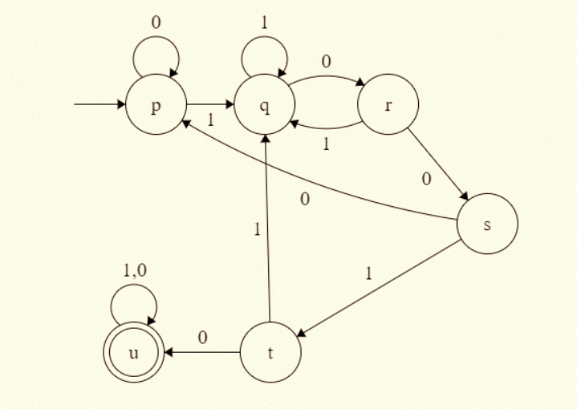

QUESTION 02

Λ

c

Λ

Λ

Λ

Λ

a

b

Λ

Λ

Λ

Λ

0

1

2

b

b

b

3

4

5

8

6

7

9

10

11

Λ

Λ

Λ

0

1

5

2

Λ

a

c

Λ

Λ

Λ

Λ

4

6

7

8

b

c

c

c

9

3

10

1. L1 ⋃ L2 = [cb+b(a|b)*] | [(ab|c)*c+c]

Λ

c

Λ

Λ

Λ

Λ

a

b

Λ

Λ

Λ

Λ

1

2

3

b

b

b

4

5

6

9

7

8

10

11

12

Λ

Λ

Λ

13

14

18

15

Λ

a

c

Λ

Λ

Λ

Λ

17

19

20

21

b

c

c

c

22

16

23

0

24

Λ

Λ

Λ

Λ

QUESTION 03

1. Yellow – 1st Pass

Blue – 2nd Pass

No 3rd Pass

1

2

3

4

5

|  |  |  |  |  |
| --- | --- | --- | --- | --- |
|  |  |  |  |  |
|  |  |  |  |  |
|  |  |  |  |  |
|  |  |  |  |  |
| 0 |  |  |  |  |

1

2

4

3

Equivalence Classes;

**{3,4,5}**

**{1,2}**

**{0}**

1. 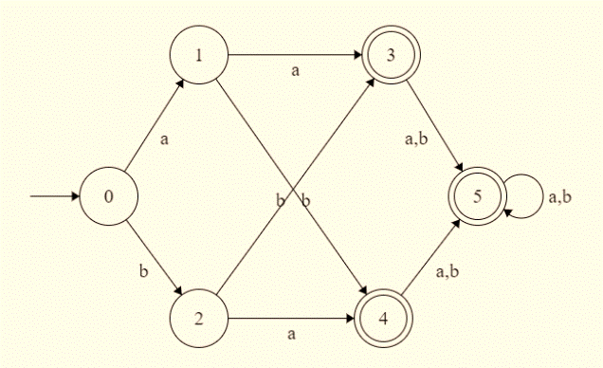

C3

C2

C1



Transition Diagram for minimized DFA

a,b

a,b

a,b

C3

C2

C1

1. It will accept a or b (a|b) and another a or b (a|b) and anything afterwards (a|b)*. This means it will accept any string of length >= 2 for the given language.

**Regular Expression : (a|b)(a|b)(a|b)* or (a|b)(a|b)+**

QUESTION 04

|  |  |  |  |  |  |
| --- | --- | --- | --- | --- | --- |
| q | δ(q, Λ) | δ(q, a) | δ(q, b) | δ*(q, a) | δ*(q, b) |
| 0 | Ø | {1} | {3} | {1,2,3} | {1,2,3} |
| 1 | {2,3} | Ø | Ø | {1,2,3} | Ø |
| 2 | Ø | {3} | Ø | {1,2,3} | Ø |
| 3 | {1} | Ø | Ø | {1,2,3} | Ø |

a

1

a

a

a

a,b

a

a,b

2

0

a

a

a,b

a

3

a

a

a,b

0

1

|  |  |  |
| --- | --- | --- |
| q | δ*(q, a) | δ*(q, b) |
| {0} | {1,2,3} | {1,2,3} |
| {1,2,3} | {1,2,3} | Ø |

QUESTION 05

1. (a|bab*a|bb)*b

$P→aP$ $Q→aR$ $R→aP →bQ$ $→bP$ $→bR$ $→$

$$R=aP+bR=b^{*}aP \\ Q=aR+bP+=ab^{*}aP+bP+=\left(ab^{*}a+b\right)P+ \\ P=aP+bQ \\ =aP+b\left(\left(ab^{*}a+b\right)P+\right) \\ =\left(a+bab^{*}a+bb\right)P+b \\ ={\left(a\left|bab^{*}a\right|bb\right)}^{*}b$$

1. (a|ab+|b+ab*)a
$$0→a2 1→a3 2→a 3→a \\ 0→b1 1→b1 2→b3 3→b3$$

$$3=a+b3=b^{*}a \\ 2=a+b3=a+bb^{*}a \\ 1=a3+b1=ab^{*}a+b1=b^{*}ab^{*}a \\ 0=a2+b1=a\left(a+bb^{*}a\right)+b\left(b^{*}ab^{*}a\right) \\ =\left(aa\left|abb^{*}a\right|bb^{*}ab^{*}a\right)$$

$$=\left(a | ab^{+}|b^{+}ab^{*}\right)a$$

2. (10*1|0)*110

Λ

Simplified Diagram

0

Λ

1

1

Λ

0

1

1

0

Λ

QUESTION 06

1/0

INPUT / OUTPUT

0/1

1/1

0/0

1/0

0/0

1/0

0/0

1/0

0/0

D

C

E

B

A